Did you really think taking up 6 lines was the RIGHT thing to do?

* Are you aware of another way to construct a foreach loop https://www.dotnetperls.com/array-foreach

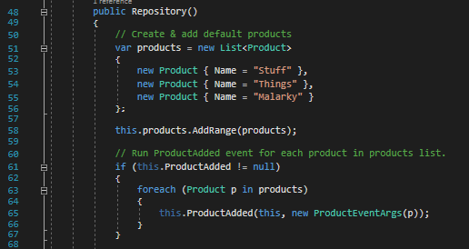

Soooo, what does any of this mean? Zero documentation, I don’t even know what language this is?

* Documentation would be recommended on these properties.

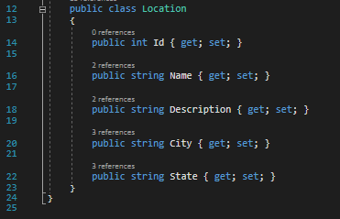

Did anyone ever teach you how to clean up? Leaving empty methods...

* I understand how C# works with abstract methods but leaving a comment in the method may help other devs.

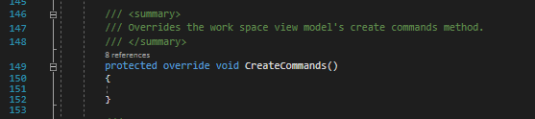

So I guess link statements don’t need to indented anymore?

* Our coding standards call for correct indentation and spacing, this code doesn’t follow those.

